ASM International
Residual Stress Technical Committee (ASM-RSTC)
Mike Hill – Committee Chair (Sept. 1, 2021 – Aug. 31, 2022), mrhill@ucdavis.edu
James Pineault – Vice Chair, xrdlab@protoxrd.com
Beth Snipes – Secretary, Beth.Snipes@tec-materialstesting.com
Notes for ASM-RSTC Meeting Aug 17, 2022
Attendees: Mike Hill, Ray Fryan, Rajan Bambroo, Dave Furrer,
Gabe Grodzicki, James Pineault, Jeff Bunn, Karen Marken,
Lynn Ferguson, Scott Henry, Beth Snipes, Jason Sicotte, Andrew Payzant,
Tony Yao, Steve Ferdon, Seung-Yub Lee, Foroogh, Eckhard Mueller,
Lesley Frame, John Watton, JP Thomas, Mark Newby, Amanda Brieger,
Mark James, Toshi Suzuki, Jason Scheuring, Iuliana Cernatescu,
Adrian DeWald, Casey Gales, Mohammed Belassel, Al Conle,
Tom Lachtrupp, Philippe Bocher

TODAY:
Election of officers (ballot out by tomorrow)
Note from Dave F: new officer recognition at IMAT
Scott H says ASM does plan to recognize TCs
Brief subcommittee reports
Action items
Adjourn
New members today:
- None

Action items for members:
- New members please fill in roster information form https://forms.gle/3YwCTEWGz9NtG5nHA
Assume active members have done so
- Consider advertising the committee when presenting at professional meetings (small or large)
See 1-slide advert for ASM-RSTC in the latest newsletter
- Report RS-related society/organization activities to Mike Hill (mrhill@ucdavis.edu). RSTC will build a list of other professional organizations we link to (such as specific committees/codes/documents organized under ASTM, ASME, ISO, SAE, SAE/FD&E, ICRS, ECRS, ICSP, AWS, MA2JIC consortium, etc.)
- Report University RS activities to Joe Rasche via email (joe.rasche@ansys.com)
ASM will contribute Poster to North America Materials Science Educators Conference that will cover RSTC and other ASM TCs; capstone projects; student presentations; etc.
TCs include RSTC, Process Modeling, Advanced Manufacturing, Materials Data Management
RSTC could link with the other ASM TCs
Ray Fryan gave a poster to Mat Sci Organization leaders
will relay information to RSTC and the other TCs very soon
will relay poster to team, too
- Recruit new members, especially developing engineers and students
Beth has provided an intro email that RSTC members can forward to university colleagues and directly to students
Jeff B plans to send RSTC student email over to MA2JIC consortium
- New web page for ASM-RSTC
https://www.asminternational.org/residual-stress-technical-committee
Thank you Scott Henry and Nicole Hale at ASM!!
Could we help Google find this page in some way?
Can ASM push RSTC information to the ASM LinkedIn channel
Scott H suggested that the ASM Social team could help
RSTC charter was sent out for review by the members
One suggestion was to state that the committee is for purposes of developing technology
and not for purposes of sales and marketing
Mike Hill suggests that we discuss this at the Sept. meeting, with proposed changes to Charter!
- Suggest presentation topics for future meetings
  - Student presenters especially welcome; contact James Pineault (xrdlab@protoxrd.com)
  - “Back to basics” presentations are very welcome

Notes captured during meeting
Standing Agenda for Residual Stress Committee:
- Subcommittee reports
  - Industry Standards (Dale Ball, Chair, dale.l.ball@lmco.com)
AMS RS Standard (Dale Ball): no update from Dale. Mike will ask for an email update.

  - Residual Stress Handbook (Dave Furrer, Chair, david.furrer@prattwhitney.com; Karen Marken supporting)
Developed “9 steps to handbook creation”
establishing dates to get these steps moving forward
Will call subcommittee meeting to confirm dates and actively work toward moving project forward

  - Newsletter (co-Chairs:
Beth Snipes, Beth.Snipes@tec-materialstesting.com
Ben Wang, wang.ben@cummins.com )
Need a new member or two. Please follow up with Beth if you can help.
Send newsletter items to Ben Wang
Please contribute:
Members in the News (new)
Did you know? or Trivia items (new)
Your ideas for new features
Describe student progress or items
James Pineault to be featured in next letter, as rising Chair
Handbook divisions will be covered in subsequent issues. Dave F. will work with us to get these divisions covered in the newsletter.
  - Education and Chapter Outreach (Jeff Bunn, Chair, bunnjr@ornl.gov)
Members: Bunn, Hill, Ben Salah, Snipes, Sicotte, Styger, Furrer, Belassel
Residual Stress 101 given at SEM Annual Meeting, Pittsburgh, June 12, 2022
Stress Analysis Workshop at DXC 2022 (Tom Watkins, Jeff Bunn, Cev Noyan), 1-5 Aug 2022 in Washington, DC, Jeff Bunn advertised RSTC at this meeting.
Workshop at AeroMat 2023, Fort Worth, TX, March 14-16
Workshop on 12 or 13 March, potentially and TBD
Jeff organizing proposal for AeroMat consideration
Dave F suggests visiting UNT (Vijay V)
  - Professional Meetings. Conferences, Symposia (Lesley Frame, Chair)
See list in newsletter.
Members: please volunteer to develop sessions for conferences you relate to and inform Lesley. Rajan Bhambroo has volunteered to help Lesley on this subcommittee. Thank you Rajan!
DXC 2022 program is available here:
https://www.dxcicdd.com/assets/2022/2022-DXC-Program.pdf
Creep related meeting in 2023
https://engineering.purdue.edu/MSE/CREEP/CREEP2023
ECRS-11, Prague, Sep 9-13, 2024
AeroMat 2023, Ft Worth, TX, March 14-16, Abstracts due Sep 30, 2022
https://www.asminternational.org/web/aeromat-2023
ICF-15 in Atlanta, June 2023, Residual Stress Symposium
Abstracts due Oct 1, 2022
IMAT meeting in Sept 2022,
Potential for f2f meeting?
informal “stress relief” meeting, beverage optional
Technical Committee Summit at IMAT on Sunday night, 5pm, dinner provided
Per Scott Henry, ASM will have a meeting of Technical Committees on Sunday prior to the IMAT conference.
Please let Scott H know if you’d like to attend the TC Summit
Related Panel session on Tuesday featuring Dave F and Bill F
ICRS proposal for USA meeting in 2025
Contact Andrew Payzant payzanta@ornl.gov or Mike Prime prime@lanl.gov
ASM-RSTC is interested to link up with ICRS
Rajan B suggests putting the conference list on the RSTC webpage!
  - University Outreach (TBD, Chair)
Call from Joe Rasche on what academic labs are active in RS work
- New business (topics and/or activities)
We are taking nominations for RSTC Secretary. Service will start Sept. 1, 2022. Please submit nominations, including self-nominations, to Beth Snipes, beth.snipes@tec-usa.com
Several members have suggested we add a section to our charter emphasizing that we are a technical, not commercial, committee. ASM is the only entity allowed to advertise. TCs must support technical aspects with no commercial activities.
- Technical topic
None today
- Committee Logistics
  - Add a subcommittee?
    - Articulation with Other Professional Groups
Need to discuss at a future meeting

NOTE:

Next meeting will be Aug 17.
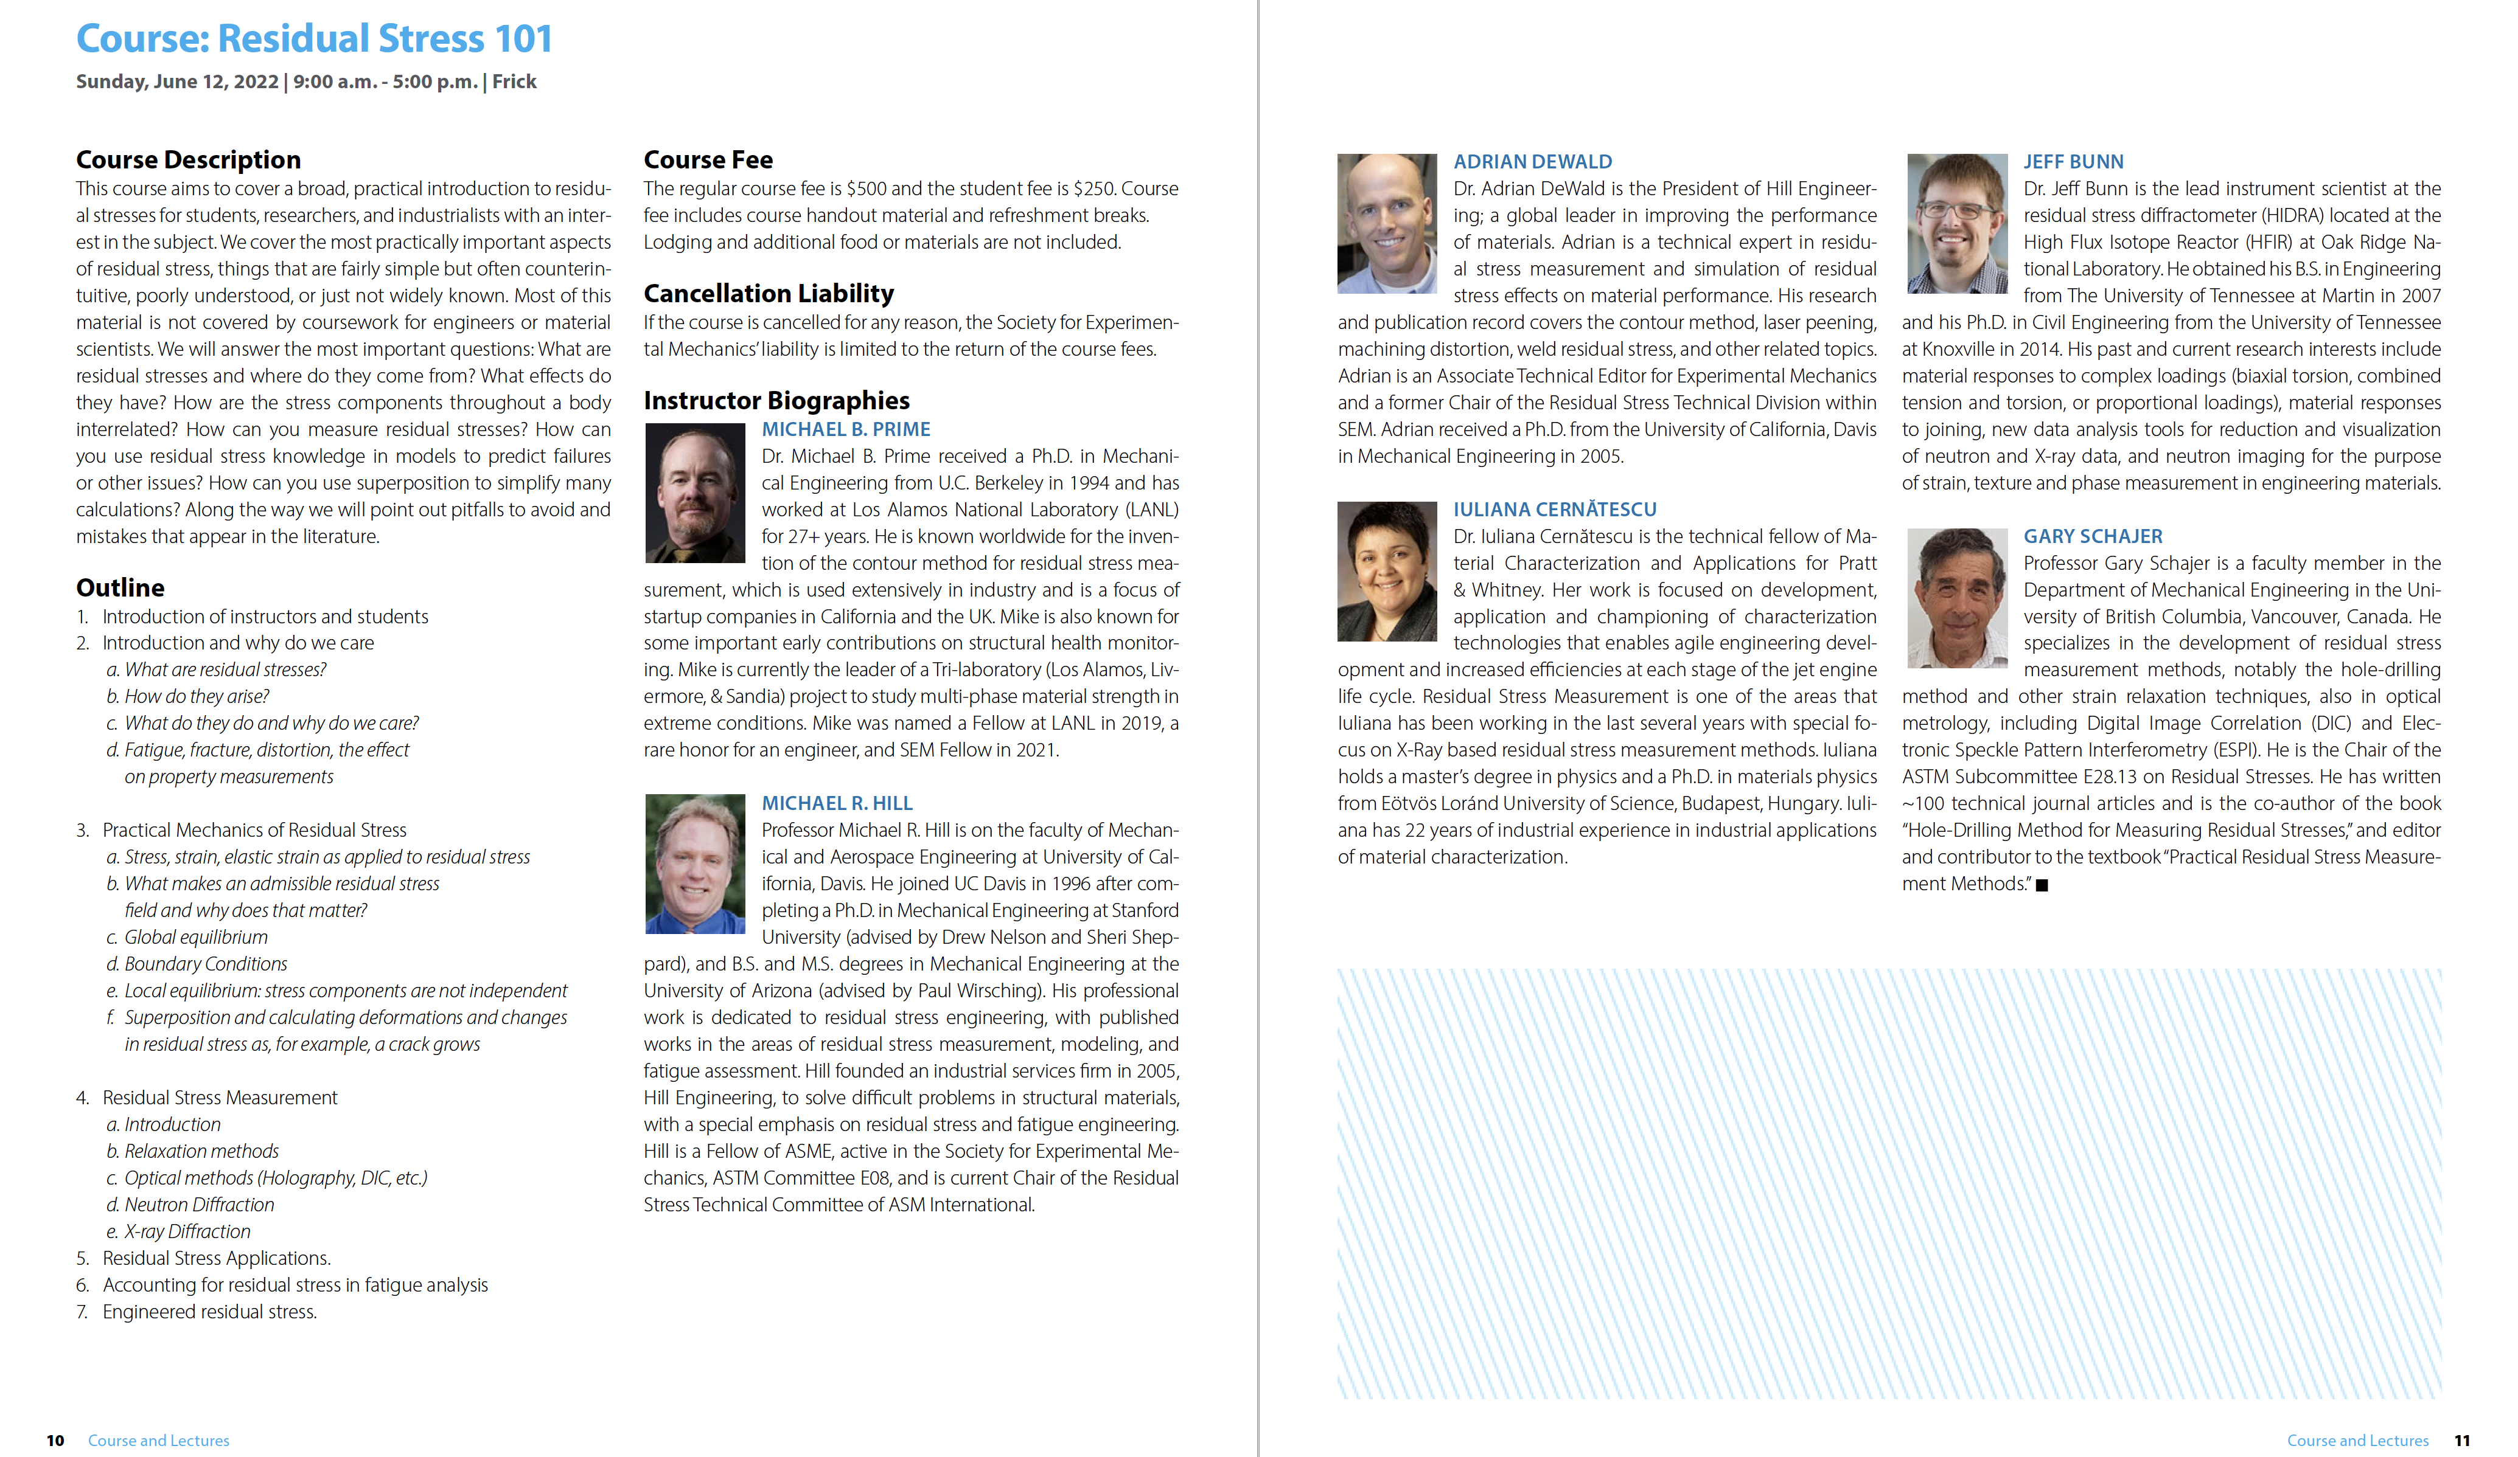
Screen shot below taken during the ASM-RSTC meeting on Jul 20, 2022

