ASM International
Residual Stress Technical Committee (ASM-RSTC)
Mike Hill – Committee Chair (Oct 1, 2021 – Sep 30, 2022), mrhill@ucdavis.edu
James Pineault – Vice Chair, xrdlab@protoxrd.com
Beth Snipes – Secretary, Beth.Snipes@tec-materialstesting.com
Notes for ASM-RSTC Meeting July 20, 2022
Attendees: Zoom window screenshots are provided at the bottom. Ray Fryan, Rajan Bambroo, Dave Breuer, Ted Reutzel, Dave Furrer, Gabe Grodzicki, James Pineault, Jeff Bunn, Jeff McDougall, Jim Harrison, John Watton, Karen Marken, Lynn Ferguson, Mark James [412-266-0135 (Mark James)], Scott Henry, Tom Lachtrupp, Beth Snipes, Al Conle, Jason Sicotte, Andrew Payzant, Tony Yao, Steve Ferdon, Seung-Yub Lee

TODAY:
Brief subcommittee reports
Action items
Adjourn
Possible f2f meeting at IMAT (Dave Furrer)
New members today:
- None

Action items for members:
- New members please fill in roster information form https://forms.gle/3YwCTEWGz9NtG5nHA
Assume active members have done so
- Consider advertising the committee when presenting at professional meetings (small or large)
See 1-slide advert for ASM-RSTC in the latest newsletter
- Report RS-related society/organization activities to Mike Hill (mrhill@ucdavis.edu). RSTC will build a list of other professional organizations we link to (such as specific committees/codes/documents organized under ASTM, ASME, ISO, SAE, SAE/FD&E, ICRS, ECRS, ICSP, etc.)
- Mike Hill announced the Easi-Stress project in EU. They are looking for participation from diffraction practitioners.
- SAE FD&E will have their Spring Meeting in June. Beth Snipes spoke at SAE FD&E in June.
- ASTM E28.13 will have their meeting June 1. Beth Snipes spoke at ASM-RSTC in June.
- Report University RS activities to Joe Rasche via email (joe.rasche@ansys.com)
ASM will contribute Poster to North America Materials Science Educators Conference that will cover RSTC and other ASM TCs; capstone projects; student presentations; etc
TCs include RSTC, Process Modeling, Advanced Manufacturing, Materials Data Management
RSTC could link with the other ASM TCs
Ray Fryan is finalizing a poster for this meeting
- Recruit new members, especially developing engineers
- RSTC Charter on ASM Connect
(https://connect.asminternational.org/communities/community-home?CommunityKey=d4811acc-211c-4e4d-b471-6a5a3645a93d )
Note: the above document appears to be missing; does anyone have a copy?
Note 2: the document was found! We’ll get a link for it up soon.
Here is a PPTX file from time committee was established (January 2020)
https://connect.asminternational.org/HigherLogic/System/DownloadDocumentFile.ashx?DocumentFileKey=02592a63-c627-94f0-87d5-e369da16e593&forceDialog=0

- Suggest presentation topics for future meetings
  - Student presenters especially welcome; contact James Pineault (xrdlab@protoxrd.com)
  - “Back to basics” presentations are very welcome

Notes captured during meeting
Standing Agenda for Residual Stress Committee:
- Subcommittee reports
  - Industry Standards (Dale Ball, Chair, dale.l.ball@lmco.com)
AMS RS Standard (Dale Ball): comments from SAE Committee B ballot being addressed
Release of USAF Structures Bulletin: https://daytonaero.com/wp-content/uploads/EZ-SB-17-001.pdf
Other standards:
ISO-21432: Non-destructive testing — Standard test method for determining residual stresses by neutron diffraction (revised 2019, original pub 2004)
Cold-worked holes standard
Energy-dispersive XRD standard through Easi-Stress
ASTM E08.06.01 new appendix on Kres to E647 – measure Kres during FCGR testing. At subcommittee level, in development.
  - Residual Stress Handbook (Dave Furrer, Chair, david.furrer@prattwhitney.com)
Last meeting 5/20/22; TOC defined, leads defined, working on ways to collaborate on documents; Will pull committee together to establish milestones and schedule.
Karen Marken now supporting as Steve Lampman retired. Farewell, Steve!
  - Newsletter (co-Chairs:
Beth Snipes, Beth.Snipes@tec-materialstesting.com
Ben Wang, wang.ben@cummins.com )
Need a new member or two. Please follow up with Beth if you can help.
Send newsletter items to Ben Wang
Please contribute:
Members in the News (new)
Did you know? or Trivia items (new)
Your ideas for new features
Describe student progress or items
Put newsletters in consistent place, such as asm.org/rstc/newsletter_v1n1.pdf
Scott Henry will check into possibilities and work to make this happen.
Beth Snipes will send a letter to Ted Reutzel and RSTC requesting student submissions to the newsletter. She will also contact Joann, editor of AM&P, to see if we can continue to have articles/newsletter published in the magazine. Mike Hill suggested posting to Higher Logic.
  - Education and Chapter Outreach (Jeff Bunn, Chair, bunnjr@ornl.gov)
Members: Bunn, Hill, Ben Salah, Snipes, Sicotte, Styger, Furrer, Belassel
Residual Stress 101 given at SEM Annual Meeting, Pittsburgh, June 12, 2022
11 attendees. Positive reviews. Main suggestion is to run as 2 half days.
Course description pasted in below.
Dave Furrer suggested posting lectures to the committee files. Permissions would be needed to use the lectures for future workshops.
Stress Analysis Workshop at DXC 2022 (Tom Watkins, Jeff Bunn, Cev Noyan), 1-5 Aug 2022 in Washington, DC
Workshop at AeroMat 2023, Fort Worth, TX, March 14-16
Workshop on 12 or 13 March, potentially and TBD
  - Professional Meetings. Conferences, Symposia (Lesley Frame, Chair)
Needs additional members to support. Rajan Bhambroo has volunteered to assist Lesley. We’ll use google form to ask for help!
See list in newsletter.
Could update newsletter with context for acronyms
SEM, week of June 12: roughly 35 presentations on residual stress; 1 special issue
ECRS-11, Prague, Sep 9-13, 2024
ICF-15 in Atlanta, June 2023, Residual Stress Symposium
Oct 1 abstracts due
IMAT meeting in Sept 2022,
Potential for f2f meeting?
informal “stress relief” meeting, beverage optional
Technical Committee Summit at IMAT on Sunday night, 5pm, dinner provided
Per Scott Henry, ASM will have a meeting of Technical Committees on Sunday prior to the IMAT conference.
ICRS proposal for USA meeting in 2025
Contact Andrew Payzant payzanta@ornl.gov or Mike Prime prime@lanl.gov
ASM-RSTC is interested to link up with ICRS
  - University Outreach (TBD, Chair)
Call from Joe Rasche on what academic labs are active in RS work
- New business (topics and/or activities)
We are taking nominations for RSTC Secretary. Service will start Oct. 1, 2022. Please submit nominations, including self-nominations, to Beth Snipes, beth.snipes@tec-usa.com
- Technical topic
None today
- Committee Logistics
  - Add a subcommittee?
    - Articulation with Other Professional Groups
Need to discuss at a future meeting

NOTE:

Next meeting will be Aug 17.
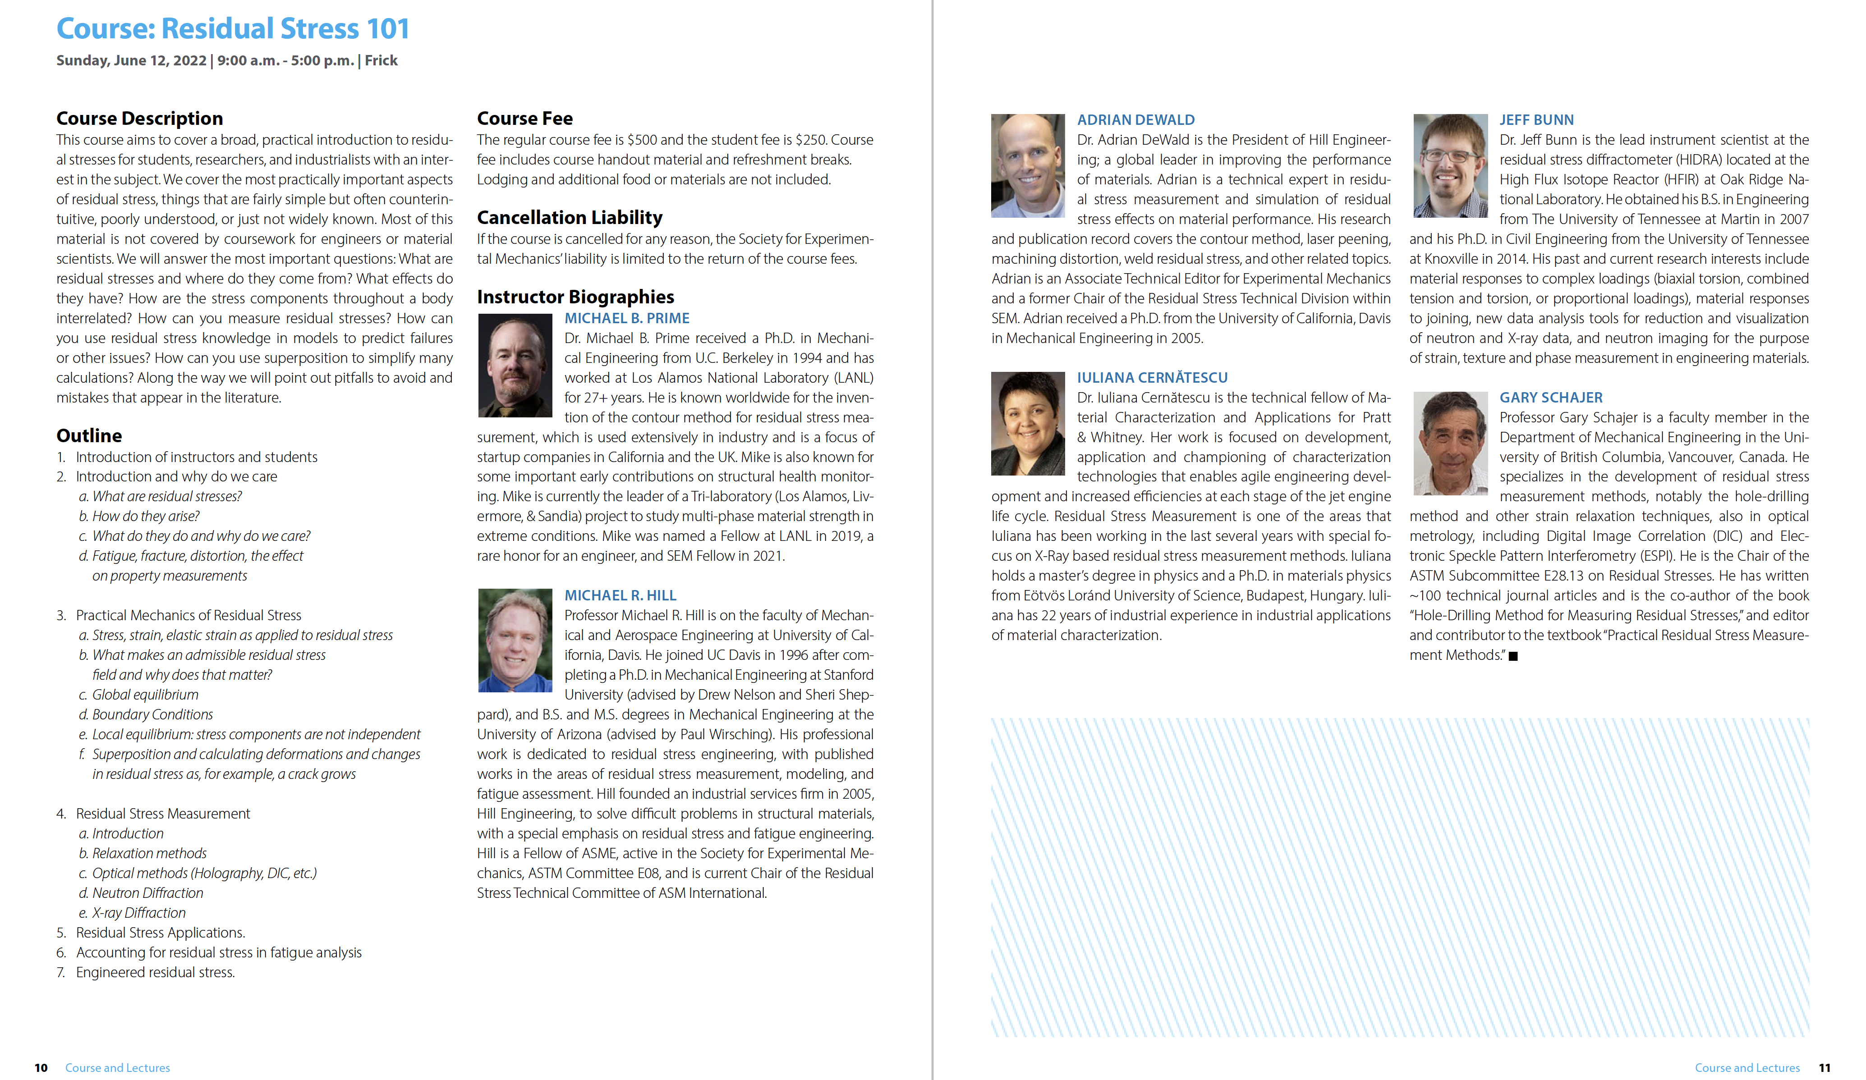
Screen shot below taken during the ASM-RSTC meeting on Jul 20, 2022

