Fig. 1 - Sections of top liquid nitrocarburized layers on Armco Iran and C10 steel. Treatment duration 6 h. Nital etch, original magnification: 400X.
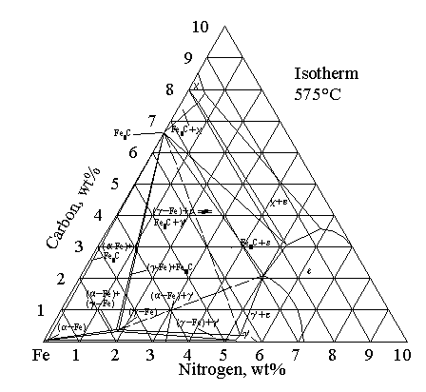

Fig. 2. Interpolated section of the metastable Fe-C-N phase diagram (at 575°C).

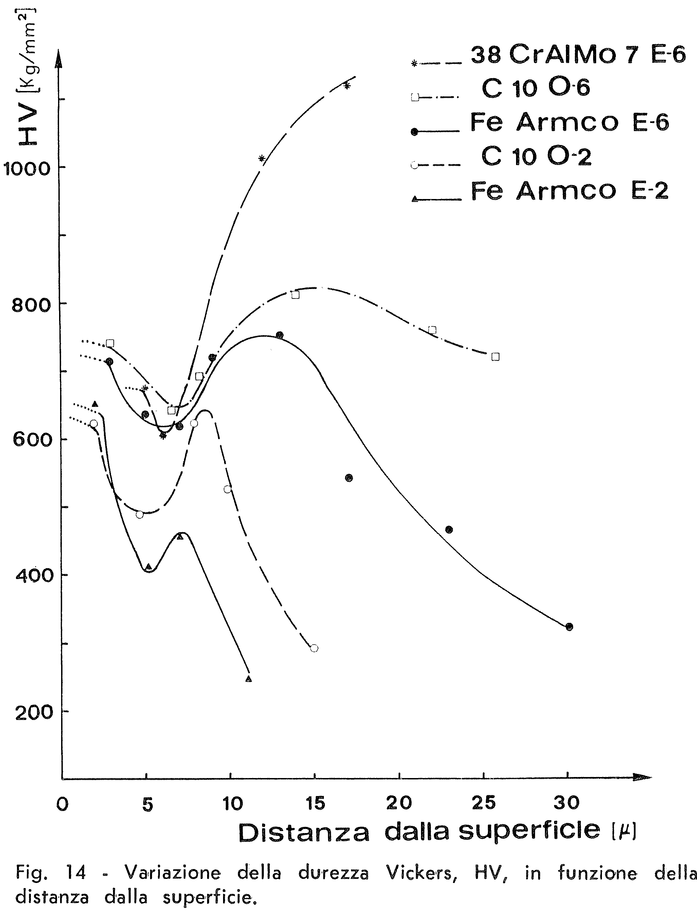

Fig. 3 - Variation of Vickers hardness as a function of the distance from surface; optimum for AISI 1010 2h liquid nitrocarburizing is the C10 O-2 curve.

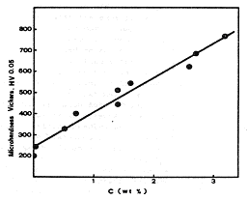

Fig. 4. Microhardness variation of compact ε-layers as a function of the C content.

