ASM International
Residual Stress Technical Committee (ASM-RSTC)
Mike Hill – Committee Chair (Oct 1, 2021 – Sep 30, 2022), mrhill@ucdavis.edu
James Pineault – Vice Chair, xrdlab@protoxrd.com
Beth Snipes – Secretary, Beth.Snipes@tec-materialstesting.com
Notes for ASM-RSTC Meeting May 18, 2022
Attendees: TBD – Zoom window screenshots are provided at the bottom
Of the newsletter.

TODAY:
Brief subcommittee reports
Technical Presentation
Dr. Scott Carlson of Lockheed-Martin Aeronautics, “Review of a Cx Hole Residual Stress Determination Method Round Robin and Some Cool Stuff Happening on the F-35 with Laser Peening”.
Action items
Adjourn
Action items for members:
- Fill in roster information form https://forms.gle/3YwCTEWGz9NtG5nHA
- Consider advertising the committee when presenting at professional meetings (small or large)
See 1-slide advert for ASM-RSTC in the latest newsletter
Send feedback to James Pineault, xrdlab@protoxrd.com
No feedback received to date.
- Report RS-related society/organization activities to Mike Hill (mrhill@ucdavis.edu). RSTC will build a list of other professional organizations we link to (such as specific committees/codes/documents organized under ASTM, ASME, ISO, SAE, SAE/FD&E, ICRS, ECRS, ICSP, etc.)
- Mike Hill announced the Easi-Stress project in EU. They are looking for participation from diffraction practitioners.
- SAE FD&E will have their Spring Meeting in June.
- ASTM E28.13 will have their meeting June 1. Beth Snipes will request time to talk about ASM-RSTC.
- Report University RS activities to Joe Rasche via email (joe.rasche@ansys.com)
- Recruit new members, especially developing engineers
  - Anyone new today? Rajan Bhambroo and Craig Bridges
- See RSTC Charter on ASM Connect (https://connect.asminternational.org/communities/community-home?CommunityKey=d4811acc-211c-4e4d-b471-6a5a3645a93d )
- Suggest presentation topics for future meetings
  - Student presenters especially welcome; contact James Pineault (xrdlab@protoxrd.com)
Summary items

Notes captured during meeting
Standing Agenda for Residual Stress Committee:
- Subcommittee reports
  - Industry Standards (Dale Ball, Chair, dale.l.ball@lmco.com)
AMS RS Standard (Dale Ball): email update says ballot by SAE Committee B imminent
Release of USAF Structures Bulletin: https://daytonaero.com/usaf-structures-bulletins-library/
Other standards:
ISO-21432: Non-destructive testing — Standard test method for determining residual stresses by neutron diffraction (revised 2019, original pub 2004)
Cold-worked holes standard
Energy-dispersive XRD standard through Easi-Stress
  - Residual Stress Handbook (Dave Furrer, Chair, david.furrer@prattwhitney.com)
Division meetings are on-going, developing best practices to finalize division scopes. Moving forward, things are taking form. Friday, 2pm EDT is next subcommittee meeting. Schedule coming together along with project plan.

  - Newsletter (co-Chairs:
Beth Snipes, Beth.Snipes@tec-materialstesting.com
Ben Wang, wang.ben@cummins.com )
Send newsletter items to Ben Wang
April newsletter has been published.
New item for newsletter: “Members in the News”. Please contribute. Also, please contribute to Trivia section.
Question from Nihad: where can we find all the newsletters? Answer: newsletters are posted to Connect, but that’s only a partial solution.
Can we do something like: Link to asm.org/rstc/newsletter_v1n1.pdf et cetera
Scott Henry will check into possibilities.
  - Education and Chapter Outreach (Jeff Bunn, Chair, bunnjr@ornl.gov)
Members: Bunn, Hill, Ben Salah, Snipes, Sicotte, Styger, Furrer, Belassel
Residual Stress 101 to be given at SEM Annual Meeting, Pittsburgh, June 12, 2022
Stress Analysis Workshop at DXC 2022 (Tom Watkins, Cev Noyan), 1-5 Aug 2022
Workshop at AeroMat 2023, Fort Worth, TX (to be planned)
  - Professional Meetings. Conferences, Symposia (Lesley Frame, Chair)
See list in newsletter
Could update newsletter with context for acronyms
SEM, week of June 12, will have residual stress sessions.
ECRS-11, Prague, Sep 9-13, 2024
IMAT meeting in Sept 2022,
ICRS proposal for USA meeting in 2025
Contact Andrew Payzant payzanta@ornl.gov or Mike Prime prime@lanl.gov
ASM-RSTC is interested to link up with ICRS
  - University Outreach (TBD, Chair)
Call from Joe Rasche on what academic labs are active in RS work
- New business (topics and/or activities)
None discussed

- Technical topic
Dr. Scott Carlson of Lockheed-Martin Aeronautics, “Review of a Cx Hole Residual Stress Determination Method Round Robin and Some Cool Stuff Happening on the F-35 with Laser Peening”.
Slides from these excellent presentations will be sent out by Mike Hill.
- Committee Logistics
  - Add a subcommittee?
    - Articulation with Other Professional Groups
Need to discuss at a future meeting

Next meeting will be June 15 chaired by James Pineault.

Screen shot below taken during the ASM-RSTC meeting on May 18, 2022

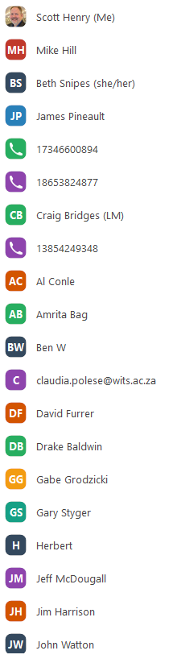 | 