ASM International
Residual Stress Technical Committee (ASM-RSTC)
Mike Hill – Committee Chair (Oct 1, 2021 – Sep 30, 2022), mrhill@ucdavis.edu
James Pineault – Vice Chair, xrdlab@proto.com
Beth Snipes – Secretary, Beth.Snipes@tec-materialstesting.com

Notes for ASM-RSTC Meeting Jan 19, 2022
Attendees: Claudia Polese, Dave Furrer, Andrew Payzant, James Pineault, Jeff Bunn, Andrew Venter, Beth Snipes, Dave Breuer, Deon Marais, Jim Harrison,
Gabe Grodzicki, Jason Scheuring, Jason Sicotte, Jeff McDougall, DTI - Nikolaj Zangenberg, Casey Gales, John Watton, K Gagliano, Lynn Ferguson, Nihad Ben Salah, Salah Rahimi, Scott Henry, Mark James, Mike Hill, Gary Styger,
Robert Reid, Amrita Bag, Ted Reutzel, Foroogh Hosseinzadeh, Diana Essock,
Eckehard Mueller, Steve Ferdon, Ray Fryan, Ania Paradowska, 814 phone, Adrian DeWald, 2 unidentified “guests”

TODAY:
Brief subcommittee reports
Technical Presentation
None
Action items
Adjourn
Action items for members:
- Send updated roster information to Dave Furrer (see email request from Dave (david.furrer@prattwhitney.com).
  - Refer to XLSX document during meeting
  - Jeff Bunn will make a google sheet for filling out!!
  - PLEASE take on the task
  - Email to follow
- Consider advertising the committee when presenting at professional meetings (small or large)
Action for Exec: develop a 1-slide advert for ASM-RSTC to be used by committee members
James will lead, Beth and Mike will help
- Report RS-related society/organization activities to Mike Hill (mrhill@ucdavis.edu). RSTC will build a list of other professional organizations we link to (such as specific committees/codes/documents organized under ASTM, ASME, ISO, SAE, ICRS, ECRS, ICSP, etc.)
- Report University RS activities to Joe Rasche via email (joe.rasche@ansys.com)
- Recruit new members, especially developing engineers
  - New today: Casey G, Foroogh H, Nikolaj Z, Jeff M, Salah R, Claudia P, Robert R, Andrew V, Ania P, Deon M
  - See RSTC Charter on ASM Connect (https://connect.asminternational.org/communities/community-home?CommunityKey=d4811acc-211c-4e4d-b471-6a5a3645a93d )
- Suggest presentation topics for future meetings
  - Student presenters especially welcome; contact James Pineault (xrdlab@protoxrd.com)
Summary items
We’ve added a Secretary to help support ASM-RSTC: Beth Snipes. Thank you, Beth!

Notes captured during meeting
Standing Agenda for Residual Stress Committee:
- Prior meeting summary
  - See notes sent by email
- Quick notes:
  - Any?
- Subcommittee reports
  - Industry Standards (Dale Ball, Chair)
AMS RS Standard (Dale Ball): TBD
NEED another subcommittee meeting in January?
ERSI Update relates to USAF SB, link to be provided.
  - Residual Stress Handbook (Dave Furrer, Chair)
Next meeting to be scheduled soon (next week or two)
Review Table of Contents, consider how different Divisions articulate
  - Newsletter (Beth Snipes and Ben Wang, co-Chairs)
Logo Contest WE HAVE A WINNER! Dave Furrer submitted the logo below. Congratulations, Dave!
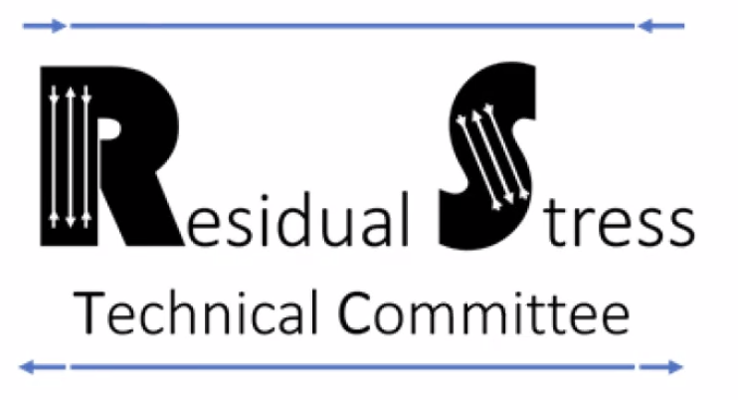
Send newsletter items to Ben Wang, wang.ben@cummins.com
  - Education and Chapter Outreach (Jeff Bunn, Chair)
Members: Bunn, Hill, Ben Salah, Snipes, Sicotte, Styger, Furrer,
Any new members?
AeroMat Workshop status (meeting date March 15-17, 2022)
Jeff B on Outline progress bunnjr@ornl.gov
March 14, 8:30-4:30pm
Pasadena, CA
Subcomm meeting next week
Nihad provided this link to a Workshop outline:
https://www.asminternational.org/documents/44016883/0/Residual+Stress+Course+-+Bunn.pdf/ac444c7f-aa2f-7b0b-5dea-6f35d307472f

Something at SEM (June 2022)?
To be discussed at next meeting
  - Professional Meetings. Conferences, Symposia (Lesley Frame, Chair)
Action for Committee: need a 1-slide advert for ASM-RSTC (plus link to RSTC Newsletters)
Volunteer?
See separate summary document (see attachment to prior minutes)
Meetings list needs to be updated, please
Aeromat: https://asm.confex.com/asm/aero22/webprogram/Session9983.html
ICRS will be in Nancy, France this year. US travel restrictions will probably make this meeting the ECRS.

  - University Outreach (TBD, Chair)
Call from Joe Rasche on what academic labs are active in RS work
- New business (topics and/or activities)
- Technical topic

- Committee Logistics
  - Add a subcommittee?
    - Articulation with Other Professional Groups
Need to discuss at next meeting

